Div 4\DEPT. OF TREATMENT SECTION-PM-CM\THERAPY SECTION-PT
MUSCLE ANATOMY REFERENCE PICTURES AND VIDEOS (SEE PAGE 3) FOR PATIENTS
PICTURES: The pictures (you can use other sources as well) can be used to learn more about the anatomy you are doing trigger points and help you understand your musculoskeletal system better.

Superficial/Large muscles:
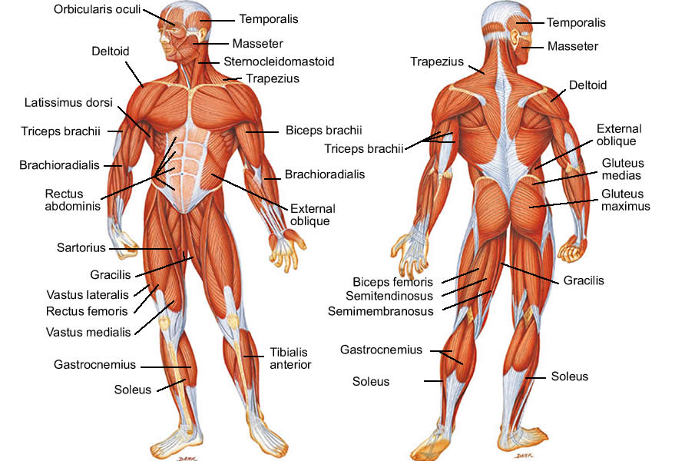

Deep hip and spine muscles on the front aspect.
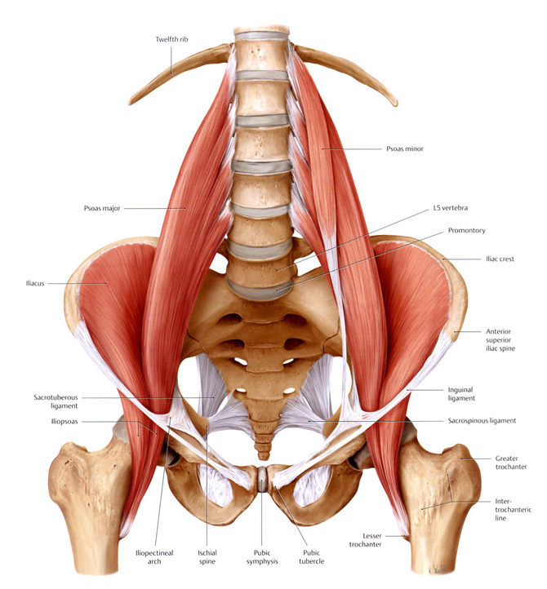

VIDEOS: The following YouTube videos (you can use other sources as well) will also help.
Neck- https://www.youtube.com/watch?v=hCyumoPPRKc
Face- https://www.youtube.com/watch?v=Tb_wKKNnRN0
Thorax/mid back/diaphragm- https://www.youtube.com/watch?v=zZLF7lw_Weo
Back and Neck (back side of)- https://www.youtube.com/watch?v=hCyumoPPRKc
Pelvis/Hip/Thigh- https://www.youtube.com/watch?v=Rs0E3KnFR1k
Lower Leg- https://www.youtube.com/watch?v=18Z-o7vbiOE
Shoulder- https://www.youtube.com/watch?v=zPjPl0wjXVM
Arm- https://www.youtube.com/watch?v=-0FZuqUPBSk
Hand/Finger- https://www.youtube.com/watch?v=jiOjnmFKxqg

