ALAMO HEIGHTS CHIROPRACTIC HEALTH CENTER
CONFIDENTIAL PATIENT INFORMATION
INSPIRING & EMPOWERING YOU TO BECOME HEALTHY & FIT TO LIVE AN AWESOME LIFE!

Name ________________________________ Birthday _____-_____-_______ Cell (_____)______-_______

Why Did You Choose AHCHC? Friend/Family/Doctor___________________ Web Page Facebook Other

How Can We Help You?
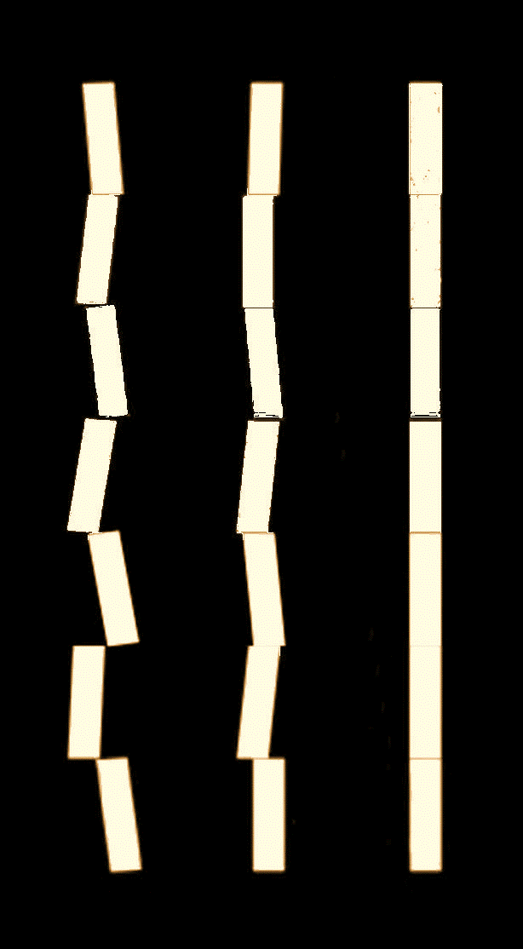
Wellness Pain Relief Correction Of Underlying Problems
Restore Health Fitness Balance Flexibility Strength
Restore Vitality Posture Quality Of Life Better Sleep Nutrition
Resume Activities Allergies Headaches Dizziness Endurance
Healthy Aging Plan Anxiety TMJ Pain Weight Loss Stress
Reduce Medications Plantar Fasciitis Sports Performance ______________ Other

What Is Your #1 Concern? _________________________________________________________________

What Does This Prevent You From Enjoying?__________________________________________________

When & How Did It Begin?___________________________________________________________________

Frequency? ______________ Intensity?____________ Rate Current Quality Of Your Life 0-10 ____

What Helps? __________________________ What Makes It Worse?_______________________________

List Other Health Concerns #2____________________________ #3______________________________

#4________________________#5____________________________ #6______________________________

What Are Your Life & Health Goals? _________________________________________________________

Tell Us About Your Life
Family Single Married Divorced Widowed In Relationship Children? Ages__________

Occupation_______________________ Employer_______________________________ Travel? ________

Favorite Activities/Hobbies_________________________________________________________________

What Lifestyle Habits Have Contributed To Your Condition? ____________________________________

Health Conditions You Have/Had ____________________________________________________________

What Age Were You The Healthiest? ______How Many Hours/Day Do You Sit?_______ Stand?________

Current Weight_____lbs. Best Wt_____lbs. Yr( ) Goal Wt_____lbs. Tallest Height _____’_____”

Who Has The Most To Gain From You Being Healthy? ___________________________________________

Physical Stress | Chemical Stress | Mental Stress
Rate Your Activity Level 0-10 ____  Accidents/Yr_______________________  __________________________________  __________________________________ | Rate Your Nutrition 0-10 _____  Medications________________________  __________________________________  __________________________________ | Rate Your Stress Level 0-10 _____  Stresses__________________________  __________________________________  __________________________________

You will have a comprehensive health examination where we will check to see if you have nerve interference caused by misalignments in your spine. These vertebral subluxations may prevent your body from being able to heal normally. Chiropractors are spinal function experts and adjust the spine to restore normal nerve & body function. We will schedule your Report of Test Findings at your earliest convenience. Patient care at AHCHC begins with a Chiropractic Health Orientation which we will schedule for you as well. We ask that you bring someone with you for these reports.

ADDRESS ______________________________________ CITY __________________ STATE______ ZIP CODE __________ WORK PHONE (___)__________ EMAIL ADDRESS ______________________________________SS#_________________

SPOUSE NAME _____________________EMPLOYER ______________________________ WORK PHONE (___) __________ NEAREST RELATIVE________________________PHONE _______________ PRIMARY PHYSICIAN ______________________

PATIENT OR GUARDIAN SIGNATURE ________________________________________________ DATE _________________
Please fill in all portions of this form and be as specific as possible. If you need help please ask.
Payment for Your Services are Due at the Time They are Received. We Provide a Statement for You to Mail to Your Insurance Company.

