

**Current Health Conditions, Medications, and Allergies**

What is the main reason for bringing your child into our office?

Has child received care for this problem before? N Y -If yes, please explain:

Current Medications:

Known Allergies:

□ Child has no known allergies to medications

**Top 3 goals you’d like to see your child reach**

1

2

3

**Confidential Child Information**

First Name: Last Name:

DOB: Gender: □ Male □ Female

Mother and Father’s Name:

Address: City: State: Zip:

Cell#: Home#:

Email:

How did you hear about Huffer Chiropractic:

Does the child see any other health professionals? □ Yes □ No Name of Dr:

Last Chiropractic Adjustment - Date: Chiropractor’s Name:



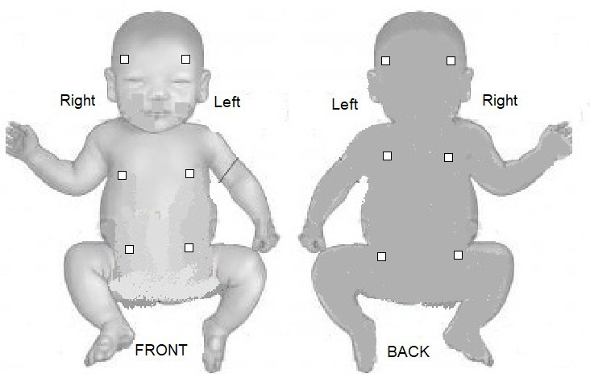

**Doctor’s History Form**

*(this page is for doctor’s use only)*

Date:

Name:

Findings:

Adjustment:

**Symptoms :**

**Traumas:**

**Toxins & Emotional Stress:**

* Pulling on head during delivery
* Forceps
* Vacuum
* Fast Delivery
* Slow Delivery
* Induction
* Epidural
* Vaccines
* Antibiotics
* Formula
* Dairy
* Gluten
* Sugar
* NICCU
* Medication
* Stressful Pregnancy
* Excessive Screen Time