What Brings You To Our Office?
If you have NO symptoms/complaints and are here for Wellness, please indicate using NONE.
List of Problems/Concerns: (most important first)
1. 2.

Frequency of MAIN problem  - Constant  - Frequent  - Intermittent  - Occasional | Better  - in the morning  - by mid-day  - by evening  - at night  - doesn't change | Relieving Factors  - sitting  - standing  - lying down  - movement  - stretching | - heat  - ice  - massage  - medication
Quality of Pain  - dull ache  - sharp  - burning  - stiffness  - numb/tingling  - radiating | Worse  - in the morning  - by mid-day  - by evening  - at night  - doesn't change | Aggravating Factors  - sitting  - driving  - standing  - bending  - lifting  - walking  - sleeping  - work activities | - coughing  - rest  - movement  - exercise  - stress  - fatigue  - household chores
Have you seen other doctors for this problem? No Yes

If yes, what treatment was received and did it help? _

No Complaints or Problems? Start Here:

Have you seen a chiropractor before?  - Yes  - No |  | When? |  | ___________ | Do you wear orthotics or arch support?  - Yes  - No
How would you rate your mattress?  - Great  - OK  - Need a better one |  | Sleeping position  - Side  - Back  - Stomach  - Change positions |  |  | How many hours do you sleep on average?  - 6-8 hours  - 4-5 hours  - 2-3 hours
Caffeine Used  - Often  - Occasionally  - Never | Exercise  - Often  - Occasionally  - Never |  | Alcohol  - Often  - Occasionally  - Never |  | Feel Stressed  - Often  - Occasionally  - Never
Average daily water intake: oz.
Vitamins/Supplements:

1.
2.
3.
4.

Please mark areas on the picture below that correspond to the areas of your body where you feel the described sensations. Mark areas of radiation. Include all affected areas.
Use appropriate symbols:
Numbness - - - - - Pins & Needles ooooo Burning xxxxx Aching ***** Stabbing /////
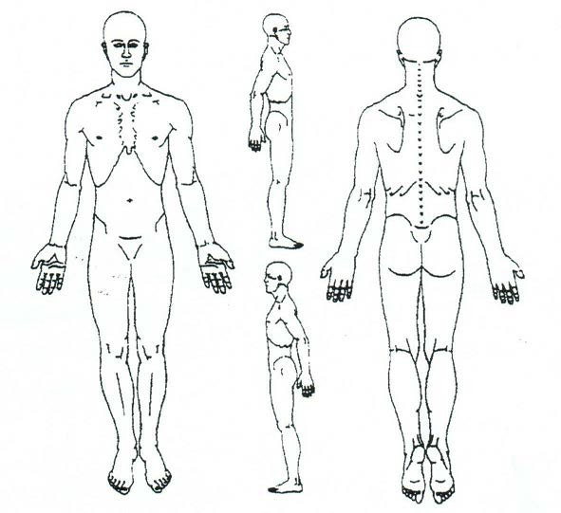

VISUAL ANALOG PAIN SEVERITY SCALE
Please place a mark on the line that corresponds to your current pain.

NO PAIN 0 1 2 3 4 5 6 7 8 9 10 WORSE PAIN EVER

Please place a mark on the line that corresponds to your average pain

NO PAIN 0 1 2 3 4 5 6 7 8 9 10 WORSE PAIN EVER

Patient Signature: Date:
Page 4 of 6

Informed Consent
I have been advised that chiropractic care, like all forms of health care, holds certain risks. While the risks are most often minimal, in rare cases, complications such as sprain/strain injuries, irritation of a disc condition, and although rare minor fractures, and possible stroke have been associated with chiropractic adjustments.
Patient Signature Date

X-Ray Consent
By my signature below I am acknowledging that the doctor and/or a member of the staff has discussed with me the hazardous effects of ionization to an unborn child, and I have conveyed my understanding of the risks associated with exposure to x-rays. After careful consideration I therefore, do hereby consent to have the diagnostic x-ray examination if the doctor has deemed necessary in my case.
Patient Signature Date

Office Financial Policy
All services rendered are the responsibility of the patient and said patient is ultimately responsible for all payment on services regardless of whether or not this office accepts insurance assignment. Our office will prequalify your insurance coverage. We will give you the best estimate of your coverage for the recommended services. This is not a guarantee of benefits. Should you discontinue care for any reason, other than discharge by the doctor, any and all balances will become due and payable. If you are on a predetermined payment plan, that plan will continue to be in effect until your balance is zero. Any expenses incurred by this office (collections, court fees, etc.) in the effort to obtain payment on unpaid accounts past 90 days will be added to your balance.
Patient Signature Date

Notice of Privacy Practices
The undersigned acknowledges receipt of a copy of the current Notice of Privacy Practices for this health care facility. It describes your rights to the limited use of protected health information, including your demographic information.
You have the right to request a restriction or disclosure on the use of your PHI (Protected Health Information). This office may or may not agree to your request.
This office utilizes open or common areas for treatment; however, private areas are available upon request. You may refuse to sign this acknowledgement and authorization and revoke this consent to use PHI. This must be done in writing.
I authorize contact from this office to confirm my appointments, treatment, and billing information by means:
Cell phone Home phone Text message
Email All of the above
Patient Signature Date

Witness
Page 6 of 6

