Dr. Jerrid Goebel Licensed Acupuncturist Dr. Stuart Johnson Dr. Al Gunderson
824 1st Street, Sturgis, SD 57785
P: 605-347-4003 F: 605-347-6929 SturgisChiro@SturgisChiro.com

Date: ________________ Social Security # ________________________

Name: _____________________________________ Birth Date: _________________ Age: ______

Mailing Address _____________________________ City______________ State ___ Zip_______

Physical Address _____________________________ City_______________ State ___ Zip_______

Email Address _______________________________ Home Phone: ___________________________

Cell Phone: _________________________________ Work Phone: ____________________________

Gender: M / F Marital Status: M / S / D / W Preferred Language: _____________________

Spouse’s or Parent’s Name: ____________________ Number Of Children: _________

Race: Caucasian / African American or Black / Native American / Asian / Hispanic / Hawaiian / Other / Decline to Specify

Occupation: _________________________________ Employer: _____________________________

Referred By: Yellow Pages __ Newspaper __ Radio __ Other __ Family/Friend/Doctor________________

Circle Appropriate Coverage: Cash Insurance Medicare Medicaid/Title19
Automobile Accident Worker’s Comp Personal Injury

Insured Name (If not patient) ____________________________ Insured Birth Date: _______________

Do You Have a Pacemaker: Y N

REASON FOR TODAY’S VISIT:____________________________________________________________

Is this condition: New Injury Old Injury Emergency Chronic Pain Wellness Visit

When Did This Condition/Accident Occur: ____/____/____ Where: _____________________________

Circle Type of Pain/Discomfort: Dull Sharp Achy Throbbing Shooting
Burning Stabbing Numbness Other_______


Rate Your Pain/Discomfort: 1 2 3 4 5 6 7 8 9 10

Does Pain Radiate/Travel in to Other Parts of Body: Y N Where:________________________

Does Your Condition Interfere With: Sleep Daily Activity Work

Recent Health Issues/Complications: _________________________________________________________

Recent Surgeries/Dates: ___________________________________________________________________

Medications: ____________________________________________________________________________

Allergies: ______________________________________________________________________________

Circle Areas of Symptoms:
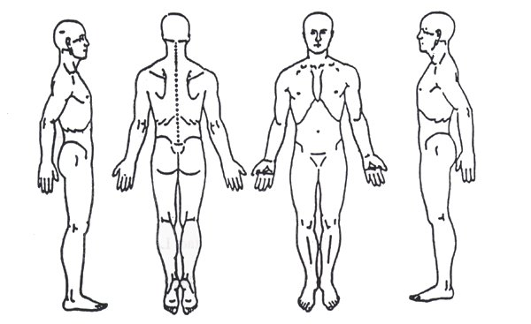

Height: ______________

Weight: ______________

Smoking Status (please circle)

Never
Former
Current Some Days
Current Every Day

Check any of the boxes that apply to you, CURRENT or PAST

□ Ear Ringing □ Tension Headache □ Angina □ Numbness
□ Earache □ Migraine □ Heart Murmur □ Tingling
□ Runny Nose □ Stiff Neck □ Heart Palpitation □ Heat Intolerance
□ Sinus Congestion □ Neck Soreness □ Stroke □ Cold Intolerance
□ Sore Throat □ Cancer □Hypertension □ Hair Changes
□ Allergies □ Depression □ Seizures □ Breast Changes
□ Difficulty Breathing □ Anemia □ Vertigo
□ Asthma □ Diabetes □ Dizziness
□ Constipation □ Muscle Pain □ Hand Trembling
□ Diarrhea □ Muscle Weakness □ Loss of Sensation
□ Heartburn/ Indigestion □ Muscle Cramps □ Uncoordinated
□ Muscle Twitching □ Weak Grip □ Abdominal Pain
□ Joint Stiffness □ Facial Paralysis □ Menstrual Cramps
□ Joint Pain □ Difficulty with Speech □ Bladder Trouble
□ Thyroid Condition □ Loss of Memory □ Urinary Trouble

Any other comments? _________________________________________________________________

Please READ AND INITIAL the following:

Acknowledgement of Receipt of Notice of Privacy Practices: I have read/acknowledged the Notice of Privacy Practices for Protected Health Information. Notice of Privacy Practices is available at the front desk upon request.
Initials _____
Payment Policy: I acknowledge I am financially responsible for all charges incurred at Sturgis Chiropractic, P.C. It is the policy of this office that payment be made at the time of service for all services rendered. A copy of this policy is available at the front desk upon request.
Initials _____
Insurance Assignment: I acknowledge that any insurance I may have is an agreement between the carrier and me and that I am responsible for the payment of any covered or non-covered services I receive.
Initials _____
Signature of Patient or Parent/Guardian _______________________________ Date ______________

INFORMED CONSENT TO TREAT

I hereby request and consent to the performance of procedures, including chiropractic adjustments, examinations, various modes of physiotherapy, acupuncture, diagnostic x-rays, and any supportive therapies on me (or on the patient named below, for whom I am legally responsible) by the Sturgis Chiropractic and /or other licensed providers and support staff who now or in the future treat me while employed by, working or associated with or serving as back-up providers, including those working at the clinic or office.

I have had an opportunity to discuss with the Sturgis Chiropractic provider and/or with other office or clinic personnel the nature and purpose of the procedures.

I understand and I am informed that, as is with all healthcare treatments, results are not guaranteed and there is no promise to cure. I further understand and I am informed that, as is with all healthcare treatments, there are some risks to treatment, including, but not limited to, muscle spasms for short periods of time, aggravating and/or temporary increase in symptoms, lack in improvement of symptoms, fractures, disc injuries, strokes, dislocation and sprains. I do not expect the Sturgis Chiropractic provider to be able to anticipate and explain all risks and complications, and I wish to rely on the doctor to exercise judgment during the course of the procedure which the doctor feels at the time, based upon the facts then known, is in my best interests.

I further understand that treatment is designed to improve health. I can also alleviate certain symptoms through a conservative approach with hopes to avoid more invasive procedures. However, like all other health modalities, results are not guaranteed and there is no promise to cure. Accordingly, I understand that all payment(s) for treatment(s) are final and no refunds will be issued.

I further understand that there are treatment options available for my condition, these treatment options include, but not limited to self-administered, over the counter analgesics and rest; medical care with prescription drugs such as anti-inflammatories, muscle relaxants and painkillers; steroid injections; bracing; and surgery. I understand and have been informed that I have the right to a second opinion and secure other opinions if I have concerns as to the nature of my symptoms and treatment options.

I have read, or have had read to me, the above consent. I have also had the opportunity to ask questions about its consent, and by signing below I agree to the above-named procedures. I intent this consent to cover the entire course of treatment for my present condition and for any future condition(s) for which I seek treatment.

Name of Patient: ______________________________________________________________________

Signature of Patient: ___________________________________________________________________

Name Printed of Guardian/Parental and Relationship to Patient: _________________________________

Guardian/Parental Signature: _____________________________________________________________

Date: ______________________

