Family Chiropractic
719-260-9611

Massage Intake Form
Client Information:
Name: | Date of Birth:
Address:
Email: | Phone:
Occupation: | Referred by:
Emergency Contact & Phone:
Massage and Medical History:
Have you had professional massage before?  Yes No |  |  |  | If yes, When was your last massage?
Do you have any allergies to massage lotion, oils, or ointment? Yes No
What kind of pressure do you like?
Mild Moderate Deep
Are you currently on any medications?
Yes No
If yes, please explain:

Please check any condition listed below that applies to you:
*=If any of these conditions apply to you, then you should not receive hot stone massage
 | Allergies/sensitivity |  | Diabetes* |  |  | Open sores or wounds*
 | Artificial joint |  | Easy bruising* |  |  | Osteoporosis
 | Atherosclerosis |  | Epilepsy |  |  | Phlebitis
 | Back/neck problems |  | Fibromyalgia |  |  | Recent accident or injury
 | Cancer* |  | Headaches/migraines |  |  | Recent fracture
 | Carpal tunnel syndrome |  | Heart condition* |  |  | Recent surgery*
 | Circulatory disorder |  | High blood pressure* |  |  | Sprains/strains
 | Contagious skin condition |  | Inflamed skin conditions* |  |  | Swollen glands
 | Current fever* |  | Joint disorder/arthritis |  |  | Tennis elbow
 | Decreases sensation |  | Low blood pressure |  |  | TMJ
 | Deep vein thrombosis/blood cots* |  | Neuropathy* |  |  | Varicose veins*
 | Taking medications that have side effects to heat*
 | Pregnancy* If so, how many months?
Please explain any condition that you have marked above:

Are you experiencing any of the following?
Dull/Ache | What area of the body? | Pain level  (1 out of 10) _________________  10 being the worst
Sharp/Stabbing | What area of the body? | Pain level  (1 out of 10) _________________  10 being the worst
Numb/Tingling | What area of the body? | Pain level  (1 out of 10) _________________  10 being the worst
Pins & Needles | What area of the body? | Pain level  (1 out of 10) _________________  10 being the worst
Burning | What area of the body? | Pain level  (1 out of 10) _________________  10 being the worst
Throbbing | What area of the body? | Pain level  (1 out of 10) _________________  10 being the worst
Cramping | What area of the body? | Pain level  (1 out of 10) _________________  10 being the worst
Radiating | What area of the body? | Pain level  (1 out of 10) _________________  10 being the worst
Other Pains | What area of the body? | Pain level  (1 out of 10) _________________  10 being the worst
Circle any specific areas you would like the massage therapist to concentrate on during the session:

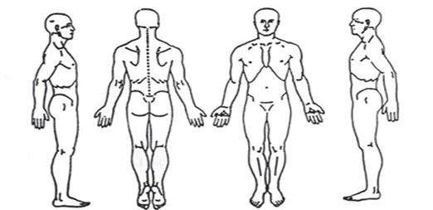

Is there anything else about your health history that you think would be useful for your massage practitioner to know to plan a safe and effective massage session for you?

Consent
I, _______________________________________________ (print name) understand that
- The massage I receive is provided for the basic purpose of relaxation and relief of muscular tension.
- If I experience any pain or discomfort during this session, I will immediately inform the therapist so that the pressure and/or strokes may be adjusted to my level of comfort.
- I further understand that massage should not be construed as a substitute for medical examination, diagnosis, or treatment and that I should see a physician, chiropractor or other qualified medical specialist for any mental or physical ailment that I am aware of.
- I understand that massage therapists are not qualified to perform spinal or skeletal adjustments, diagnose, prescribe, or treat any physical or mental illness, and that nothing said in the course of the session given should be construed as such.
- Because massage should not be performed under certain medical conditions, I affirm that I have stated all my known medical conditions, and answered all questions honestly.
- I agree to keep the therapist updated as to any changes in my medical profile and understand that there shall be no liability on the therapist’s part should I fail to do so.

Signature ______________________________________________________________________  (client or parent/legal guardian) | Date:_____________________

__________________________________________________________________________________________

Minor Consent
I ________________________________, am the parent/legal guardian of _________________________.

I hereby consent for my minor child to receive massage therapy treatments from Christina Tancik, LMT. I understand that I am financially responsible for the minor that I must schedule all appointments on their behalf. I grant permission that my child may receive treatment with or without my presence.

Signature of parent/legal guardian: | Date:

