Patient Intake Form- Therapeutic and Relaxing Massage
Personal Information: (Please print)
Date_________________
Name_______________________________________________
Type of Employment________________ Referred by__________________
Emergency Contact________________________ Phone_______________
The following information will be used to help plan a safe and effective massage session. Please answer the questions to the best of your knowledge.
Have you had a professional massage before? ___________________ How often? ___________
Do you have any difficulty lying on your front, back or side? Yes or NO
If yes, please explain _______________________________________________________
Are there any areas you do NOT like massaged? _______________________________________
_____________________________________________________________________________.
Do you have sensitive skin? Yes or No
Medical History
In order to plan a massage session that is safe and effective I need some general information about your medical history.
Are you currently under medical supervision? Yes or No
If yes, Please explain _________________________________________________________
_________________________________________________________________________________.
Name of Physician _________________________ Chiropractor _____________________________
Injuries/accidents/illnesses still affecting you ____________________________________________
_________________________________________________________________________________.
Surgeries you have had and dates _____________________________________________________
_________________________________________________________________________________.
Are you taking any medications/ supplements ___________________________________________.
Have you ever had seizures? Yes or NO
Have you ever been tested for a communicable disease? Yes or No What were the results?_______
_________________________________________________________________________________.
Please Circle any condition listed below that applies to you:

Bone or joint disease Heart condition Rashes
Tendonitis/ Bursitis Phlebitis/ Varicose Veins Athletes foot
Arthritis/ Gout Blood clots Herpes/ Cold sores
Jaw pain (TMJ) High/ Low blood pressure Impetigo
Parkinson’s Disease Thrombosis/ Embolism Psoriasis
Spinal problems Asthma/ Emphysema Cerebral Palsy
Diabetes Depression Pinched Nerve
Multiple Sclerosis Migraines/ Headaches HIV/ Aids
Numbness/ tingling Irritable bowel syndrome Ulcers
Bladder/ kidney ailment Cancer/ tumors Sleep disorder
Eating disorder Prostate Ailment Shingles/ Herpes
Osteoporosis Current Fever Tennis Elbow
Carpal Tunnel Syndrome foot pain/ Plantar Fasciitis Epilepsy
Whiplash Pregnancy (month)_______ Flu/ Cold
Anxiety/ stress disorder PMS/ menstrual problems Scoliosis
Hepatitis tuberculosis Liver ailment
Mononucleosis Fibromyalgia Sciatic pain

Please mark any areas of discomfort Other conditions not listed ________________________
_______________________________________________
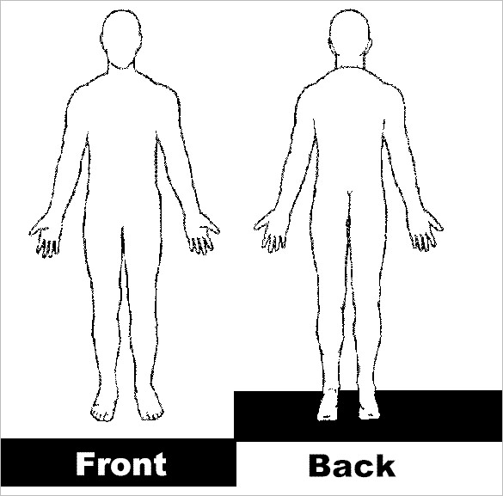
_______________________________________________.

Please explain any condition you have marked or if you have any additional remarks/ comments:
________________________________________________________________________________________________________________________________________________________________________________________________________________________________________________________________________________________________________________________________________________________________________________________________________________.
Draping will be used during the session-only the area being worked on will be uncovered. The massage is for therapeutic purposes only. No sexual innuendos or behavior will be tolerated.

10 minutes of the appointment will be needed for consultation and dressing.

Your appointment time has been reserved for you. It is required that you give 24 hours of notice to cancel your appointment. If you do not, you will then be required to put down a deposit to hold your appointment. The deposit will be in the amount of your massage. Giving us 24 hours’ notice will allow us to give your time to another patient. Please fill out payment information below so that it can be kept in your file. Please initial _______

Debit/ Credit card information:
Card # ______________________________________________ Exp _______________ V code _____

Clients under that age of 19 must be accompanied by a parent or legal guardian during the entire session. Informed consent must be provided by the parent, or legal guardian for any client under that age of 19.

I, ________________________________________ (Print name) understand that the massage I receive is intended to enhance relaxation, reduce pain caused by muscle tension, increase range of motion, and improve circulation. If I experience any pain of discomfort during the session, I will immediately inform the therapist so that the pressure and/ or strokes may be adjusted to my level of comfort. I further understand that the massage should not be construed as a substitute for medical examination, diagnosis or treatment and I should see a physician, chiropractor, or other qualified medical specialist for any mental or physical ailment I am aware of. I understand that massage therapists are not qualified to perform spinal or skeletal adjustment, diagnose, prescribe, or treat any physical or mental illness, and that nothing said in the session should be construed as such. Because massage should not be performed under certain medical conditions, I affirm that I have stated all my known medical conditions, and answered all questions honestly. I agree to keep the therapist updated as to any changes in my medical profile and understand that there shall be no liability on the therapist’s part if I fail to do so.

Signature of Patient ________________________________________Date _______________________
Signature of Massage Therapist_______________________________ Date_______________________

