Confidential Patient Information Patient ID #:___________

First Name: __________________ Middle Initial: _____ Last Name:______________________

Address: _________________________________________________________________________

City: ____________________________________ State: __________ Zip Code: ________________
Date of Birth:______________________ Age:_________ Number of Children_________
SSN:__________ -__________-____________
Spouse’s Name: __________________________ Marital Status: Married Single Widow Divorced
Occupation:__________________________________ Dominant Hand: ___Right ___Left ___Both
Email:___________________________________________________@_______________.__________
Home #: ( ) ______-_________Work#: ( )_______-__________Cell# ( )_______-____________
Emergency Contact: ___________________________________Contact # ( )________-__________
Auto Insurance Company: _______________________________Date of Injury:______-_______-_____
Auto Insurance Address:_________________________________________________________________
Policy Holder (If different than patient):____________________________________________________
Claim Number/Policy ID: ________________________________________________________________
Did you receive treatment anywhere? If so, where? __________________________________________

Attorney Information: __________________________________________________________________
Attorney Address: _____________________________________________________________________
Attorney Contact #: ( ) ____________-________________________

Description of Symptoms –
(Check off or Circle your symptoms in the sections below.)

- Headaches |  | Left | Right | Both Sides | Type of Pain: | List ALL that
 |  | Front of Head |  |  |  | Apply from
 |  | Top of Head |  |  |  | List below
 |  | Back of Head
- Jaw |  | Left | Right | Both Sides
- Eye |  | Left | Right | Both Sides
- Neck |  | Left | Right | Both Sides
- Upper Back |  | Left | Right | Both Sides
- Mid Back |  | Left | Right | Both Sides
- Low Back |  | Left | Right | Both Sides
- Chest |  | Left | Right | Both Sides
- Abdomen |  | Left | Right | Both Sides
- Ribs |  | Left | Right | Both Sides
- Buttocks |  | Left | Right | Both Sides
- Shoulder |  | Left | Right | Both Sides
- Upper Arm |  | Left | Right | Both Sides
- Forearm |  | Left | Right | Both Sides
- Hand |  | Left | Right | Both Sides
- Knee |  | Left | Right | Both Sides
- Hip |  | Left | Right | Both Sides
- Leg |  | Left | Right | Both Sides
- Foot |  | Left | Right | Both Sides
TYPES OF PAIN: |  | Dull | Sharp | Aching | Cutting | Shocking
 |  | Throbbing | Burning | Numbing | Tingling | Cramping
 |  | Spasm | Stinging | Shooting | Pounding | Constricting
Other types of pain: |  | ___________ | ___________ | __________ | __________

Patient Name:_____________________________ ID#______________ Date:____________________

Informed Consent
Health care providers are required to advise patients of the nature of the treatment to be provided, the risks and benefits of the treatment and any alternatives to the treatment. There are some risks that may be associated with chiropractic manipulation and massage treatments in particular you should note:
A. While rare, some patients have experienced rib fractures or muscle and ligament sprains or strains following treatment.
B. There have been rare reported cases of disc injuries following cervical and lumbar spinal adjustment though no scientific study has ever demonstrated such injuries are cause, may be caused, by spinal or soft tissue manipulation or treatment.
C. There have been reported cases of injury to a vertebral artery following osseous spinal manipulation. Vertebral artery injuries have been known t cause a stroke, sometimes with serious neurological impairment, and may, on rare occasion result in paralysis or death. The possibility of such injuries resulting from cervical spinal manipulation is extremely remote.
Osseous and soft tissue manipulation has been the subject of government report and multi-disciplinary studies conducted over many years which have demonstrated it to be highly effective in treatment for spinal conditions including general pain and loss of mobility, headaches, and other related symptoms. Musculoskeletal care contributes to your overall well being. The risks of injuries or complications from treatment is substantially lower than associated with many medical or other treatments, medications, and procedures given the same symptoms.
I consent to the treatment offered or recommended to me by my healthcare provider, including osseous and soft tissue manipulation. I intend this consent to apply to call my present and future care with North Florida Chiropractic Center.
Dated this __________________ day of __________ 20_______

Patient Printed Name: ____________________________________________

Patient Signature (or legal guardian): ________________________________

Dr. Laura W. McChesney D.C.
Dr. Michael T. Liuzzo D.C. Physician Signature: ____________________________
Patient Name: __________________________________ Date: _____________________
PATIENT’S STATEMENT OF PRIVACY RIGHTS
As a patient of this practice, you have the right to privacy of your Personal Health Information, and to know that such information shall be properly and securely maintained by this practice, in accordance with our own policy and in compliance with the Health Information Accountability and Portability Act of 1996 (HIPAA). HIPPA was enacted to give you, the patient of a health care provider and covered under a health insurance claim, more control over your health information, to set boundaries on the use and release of health records, establish appropriate safeguards that health care providers and others must achieve to protect the privacy of Personal Health Information, and to hold violators accountable, with appropriate penalties for violation of a patient’s right to privacy.

This notice takes effect on _______________________ and remains in effect until we replace it.
AS A PATIENT OFTHIS PRACTICE:

- You are entitled to an individually delivered, written notification of your Privacy Rights at the time of your first visit to this practice’s facility. The document you are reading is this notice. PLEASE REVIEW TO CAREFULLY.
- You are entitled to see your medical records.
- You are entitled to receive a copy of your medical records. (Forms are available upon request.) As per allowance by HIPAA the charge will be $0.10 per page.
- You are entitled to make an amendment to your patient health information within those records. (Forms are available upon request.)
- While the doctor has a right to deny inclusion of amendments into a patient file, you gave the right to disagree with the doctor’s refusal of such inclusion of amendment to those records. (Forms are available upon request.) If the doctor disagrees, he shall supply you with written notification of such disagreement.
- The doctor has a right to a rebuttal to the patient’s disagreement. But any time a file is sent out of the office, a copy of that rebuttal must be included in the file.
- You have the right to specify how access to your health information is restricted and from whom.
- You have the right to indicate the method and/or phone numbers and/or addresses to which telephonic and written communications to you shall be forwarded.
- All covered entities under HIPAA, such as this practice or other health care providers, or business associated such as billing companies or claims administrators, as are designated by the HIPAA Privacy Rule, and with whom this practice must work on your behalf from the standpoint of effective treatment or billing of medical services and administration of such services, shall be part of a “chain of trust” under applicable with those parties. This means that those parties are bound to maintain the same privacy and security of your health information, as are we.
- No personal health information shall be released to any person without a signed consent from patient.
- You are entitled to this practice’s best efforts to maintain the security of Personal Health Information on your behalf within and outside this office.
- The practice shall provide Personal Health Information to require parties on the basis of the minimum necessary standard of release (releasing only that information necessary for those parties to provide treatment, reimbursement, or administrative services on your behalf) and so as to maintain the intent of HIPAA in establishing that standard.
- You have the right to inquire of this office and gain correct and appropriate answers to any questions regarding your privacy rights at any time, consistent with those rights as covered by HIPAA.
- You have the right to contact the Depart of Health and Human Services, Office of Civil Rights, which administrates HIPAA, with questions or to file a complaint at Toll Free: 1-877-696-6775 or
Email: www.hhs.gov/ocr.
PATIENT’S AFFIRMATION OR RECEIPT OF
PATIENT’S STATEMENT OF PRIVACY RIGHTS

ACKNOWLEDGEMENT FORM
I have received this office’s Statement of Privacy Rights, provided on my behalf and in accordance with law, and have read and understand my rights to privacy and security of Personal Health Information, as a patient of this practice.

Affirmed,

Print Name: __________________________________
Birth Date:__________________________________
Signature:_____________________________________

AUTHORIZATION FOR
RELEASE OF PERSONAL HEALTH INFORMATION
I, __________________________________________ hereby authorize ________________________________________ to release my personal health information not already excepted by HIPAA ore related statutes, or other information as noted below to the part of North Florida Chiropractic Center at Millhopper Medical Center, 2341 NW 41st Street, Suite C, Gainesville, Florida 32606 for the purpose of chiropractic treatment for a period commencing on the date below and ending one year from that date.

Review of ___________________________________________________
___________________________________________________________.
I reserve the right to cancel this authorization by notification in writing to the above party to whom I have given such authorization.

Affirmed by the patient,
PRINTED NAME______________________________________________
SIGNATURE _________________________________________________
DATE _______________________
SOCAL SECURITY NUMBER ______________-_________-__________

Assignment and Authorization
For good and valuable consideration, including the agreement of North Florida REHAB and Chiropractic Center (“NFCC”) to accept this assignment in lieu of demanding full payment for services from the undersigned on the date each service is rendered, the undersigned patient executes this document hereby assigning to NFCC the right to receive insurance benefits, to me or on my behalf, for services rendered by NFCC, for a motor vehicle accident that occurred on or about ___________________.
Any insurance company that may be obligated to pay any insurance benefits to me, or on my behalf, for the aforesaid accident for services provided by NFCC, is hereby directed to issue payment for those benefits directly to and payable to NFCC.
I also authorize and assign to NFCC the right to file suite and purse all legal remedies to obtain payment for services provided to me by NFCC. This authorization to file suite is an assignment of my cause of action to obtain payment for services provided to me by NFCC and includes the assignment to pursue declaratory relief or any other legal remedies.
NFCC accepts the aforesaid assignment and hereby notifies any insurer issuing payment that NFCC objects to any “repricing” or reduction of billed amounts unilaterally made by any insurer. Any such reduced payments issued by any insurer are accepted under protest and without waiving any right of the provider to pursue all legal remedies against the insurer.
Please read this document completely before signing. If you do not completely understand this document or have any questions about this document, please ask us to explain it to you. If there is any portion of this document that you do not wish to authorize, we will remove that portion from this document. Your signature below is your agreement you fully understand this document and you fully agree to the terms of this document.

_______________________________________________ _________________________
Patient’s Signature (or Guardian’s Signature) Date

_______________________________________________
Print Patient’s Name (or Print Guardian’s Signature)

_______________________________________________ _________________________
Witness to Patient’s or Guardian’s Signature Date

_______________________________________________ _________________________
Authorized Signatory for NFCC Date

Additional Authorization and Direction to Insurer
AUTHORIZATION FOR DISCLOSURE OF INSURANCE DECLARATION PAGE: I, the patient and insured, further authorize and direct any insurance company that may be obligated to pay any insurance benefits to me, or on my behalf, to provide North Florida Chiropractic Center (“NFCC”) a copy of any declaration page of any insurance policy that may provide any insurance benefits to me for this aforesaid accident.
AUTHORIZATION FOR DISCLOSURE OF INSURANCE PAYMENT RECORD: I further authorize and direct any insurance company that may be obligated to pay any insurance benefits to me, or on my behalf, to provide to NFCC a copy of any ledger or payment record of payments made under any insurance coverage available to me, without redacting the names of any other medical provider or entity to whom insurance benefits have been paid and without redacting the amount of any insurance benefits that have been paid.
DIRECTION NOT TO EXHAUSE BENEFITS BY PAYMENT OF OTHER CLAIMS: I further authorize and direct any insurance company that may be obligated to pay any insurance benefits to me, or on my behalf, to not exhaust insurance benefits or coverage until all claims submitted by NFCC have been pain in full, or at 80% if the insurance policy is limited to pay 80% coverage of medical claims. If any insurance company obligated to pay any insurance benefits to me, or on my behalf, has denied payment or a claim submitted by NFCC, or made payment to NFCC at an amount lesser than the amount billed, or lesser than 80% of the amount billed if my coverage is limited to 80% for medical claims, I direct the aforesaid insurance company to hold in escrow the amount in dispute, and if other claims would exhaust benefits of coverage by payment of the amount I have hereby requested be held in escrow. I further authorize and direct the aforesaid insurance company to notify NFCC that benefits have been exhausted except the amount held in escrow, to enable NFCC to attempt to resolve the disputed claim in a manner acceptable to NFCC.
DIRECTION TO INURER TO MAINTAIN CONFIDENTIALITY: I further direct any insurance company that may be obligated to pay any insurance benefits to me, or on my behalf, to maintain the privacy and confidentiality of my medical records. I do not authorize any insurer to provide my medical records to anyone with first obtaining a written authorization from me to provide medical records to any other entity.
AUTORIZATION FOR RELEASE OF RECORDS TO PROVIDER: I hereby authorize any insurance company that may be obligated to pay any insurance benefits to me, or on my behalf, to release a copy of my complete medical records in possession of such insurer to NFCC upon the request of NFCC. This authorization includes the authorization to release to NFCC a copy of any medical examination or evaluation of me requested by any insurance company.
DIRECTION TO INSURER TO PROVIDE TO PROVIDER ADVANCE NOTICE OF IME OR EUO: I further authorize and direct any insurance company that may be obligated to pay any insurance benefits to me, or on my behalf, to provide at least 15 days advance notice to NFCC of any physical examination or examination under oath of myself that any insurance company may schedule.
Please read this document completely before signing. If you do not completely understand this document or have any questions about this document, please ask us to explain it to you. If there is any portion of this document that you do not wish to authorize, we will remove that portion from this document. Your signature below is your agreement you fully understand this document and you fully agree to the terms of this document.
_______________________________________________ _________________________
Patient’s Signature (or Guardian’s Signature) Date

_______________________________________________
Print Patient’s Name (or Print Guardian’s Signature)

_______________________________________________ _________________________
Witness to Patient’s or Guardian’s Signature Date

MEDICAL REPORTS AND DOCTOR’S LIEN

I do hereby authorize Michael T. Liuzzo, D.C. to furnish you, my attorney, with a full report of his examination, treatment, prognosis, ect. Of myself in regard to my accident/illness which occurred/began on ________________________.
I hereby give a lien to said doctor on any settlement, claim, judgment, or verdict as a result of said accident/illness, an authorize and direct you, my attorney, to pay directly to said doctor such sums which may be due and owing him for services rendered to me, and to withhold such sums from such settlement, claim, judgment, or verdicts that may be necessary to protect said doctor adequately.
I fully understand that I am directly and fully responsible to said doctor for all chiropractic bills submitted by him for services rendered me, and that consideration of his awaiting payment. And I further understand that such payment is not contingent on any settlement, claim, judgment or verdict by which I may eventually recover said fee.
Please acknowledge this letter by signing below and returning to the doctor’s office. I have been advised that if my attorney does not wish to cooperate in protecting the doctor’s interest, the doctor will no await payment, but will require me to make payments on a current basis.
____________________________________ ____________________________________
Patient’s Signature PRINT Patient’s Name
____________________________________ ____________________________________
Date Witness

The undersigned, being attorney of record for the above patient does hereby acknowledge receipt of the above lien, and does agree to honor the same to protect adequately said above name attorney.
Attorney’s Signature______________________________________ Dated _______________

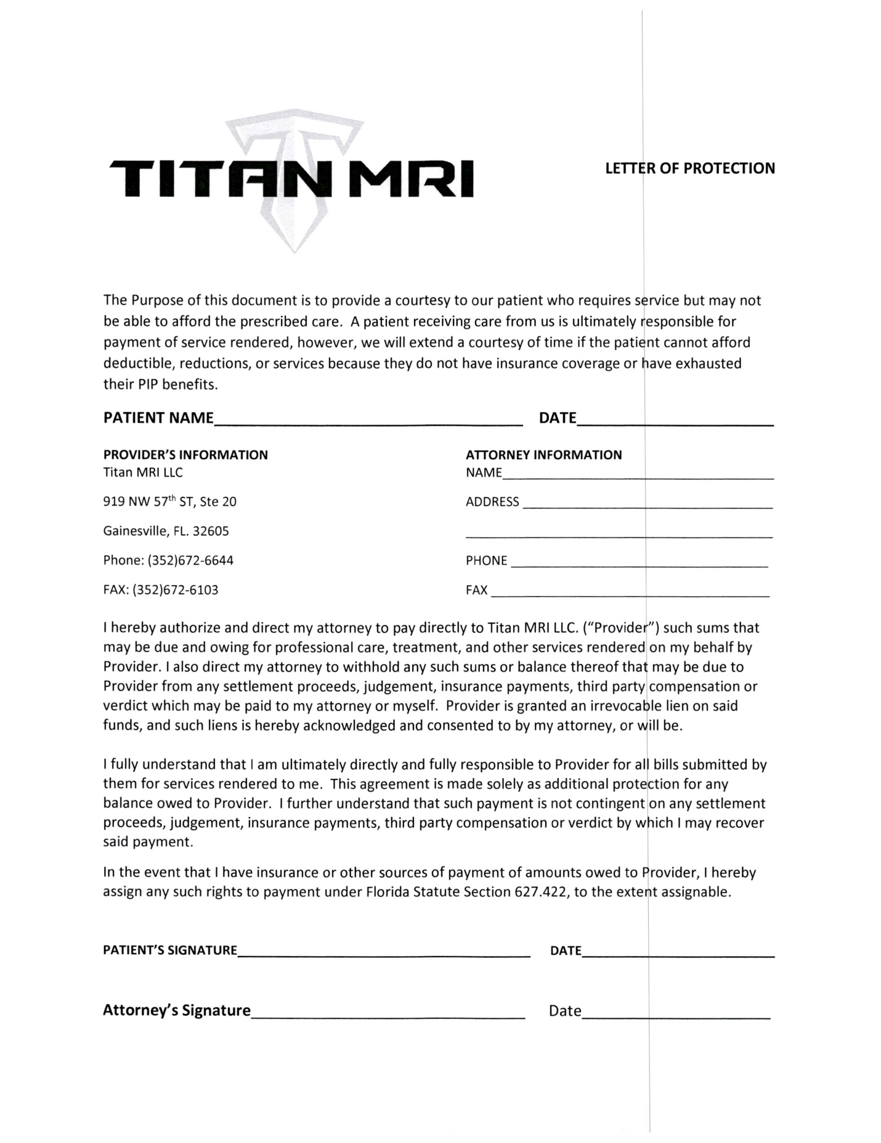

Standard Disclosure and Acknowledgement Form

Personal Injury Protection – Initial Treatment or Service Provided

The undersigned insured person (or guardian of such person) affirms:
1. The services or treatment set forth below were actually rendered. This means that those services have already been provided.
Comprehensive Examination ___________________________________________________
Chiropractic Adjustment and Physiotherapy_______________________________________
2. I have the right and the duty to confirm that the services have already been provided.
3. I was not solicited by any person to seek any services from the medical provider of the services described above.
4. The medical provider has explained the services to me for which payment is being claimed.
5. If I notify the insurer in writing of a billing error, I may be entitled to a portion of any reduction in the amounts paid by my motor vehicle insurer. If entitled, my share would be at least 20% of the amount of the reduction, up to $500.
Insured Person (patient receiving treatment or services) or Guardian of Insured Person:
____________________________ ______________________________ ______________
Name (Print or Type) Signature Date
The undersigned licensed medical professional or medical director, if applicable, affirms the statement numbered 1 above and also:
A. I have not solicited or caused the insured person, who was involved in a motor vehicle accident, to be solicited to make a claim for Personal Injury Protection benefits.
B. The treatment or services rendered were explained to the insured person, or his or her guardian, sufficiently for that person to sign this form with informed consent.
C. The accompanying statement or bill is properly completed in all material provisions and all relevant information has been provided therein. This means that each request for information has been responded to truthfully, accurately, and in a substantially complete manner.
D. The coding of procedures on the accompanying statement or bill is proper. This means that no service has been upcoded, unbundled, or constitutes an invalid or not medically necessary diagnostic test as defined by Section 627.732 (14) and (15), Florida Statutes or Section 627.736 (5)(b)6, Florida Statues.
Licensed Medical Professional Rendering Treatment/Services or Medical Director, if applicable (signature by his/her own hand):
Dr. Laura McChesney_____________ ______________________________ ______________
Name (Print or Type) Signature Date
Any person who knowingly and with intent to injure, defraud, or deceive any insurer files a statement of Claim or an application containing any false, incomplete, or misleading information is guilty of a felony of the third degree per Section 817.234(1)(b), Florida Statutes.
Note: The original of this form must be furnished to the insurer pursuant to Section 627.736(4)(b), Florida Statues and may not be electronically furnished. Failure to furnish this form may result in non-payment of the claim.
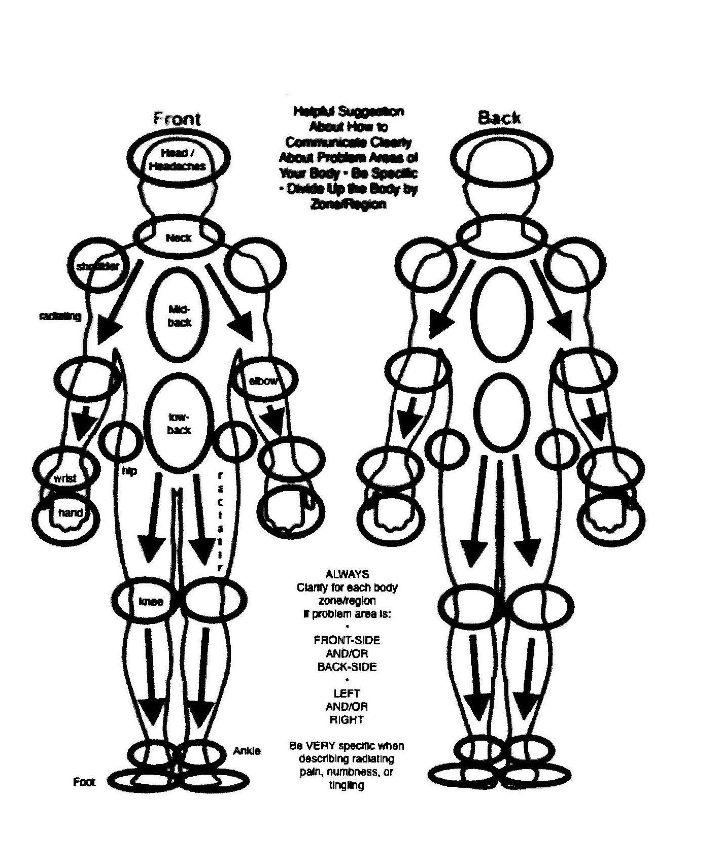
Right Left
Left Right
Right Left
Left Right
*Be VERY specific when describing radiating pain, numbness, or tingling.
*PLEASE SPECIFY IN CIRCLED AREAS PAIN LEVEL FROM 1-10 WITH 10 BEING THE HIGHEST.

Name: ______________________________________________________ Date: ________________

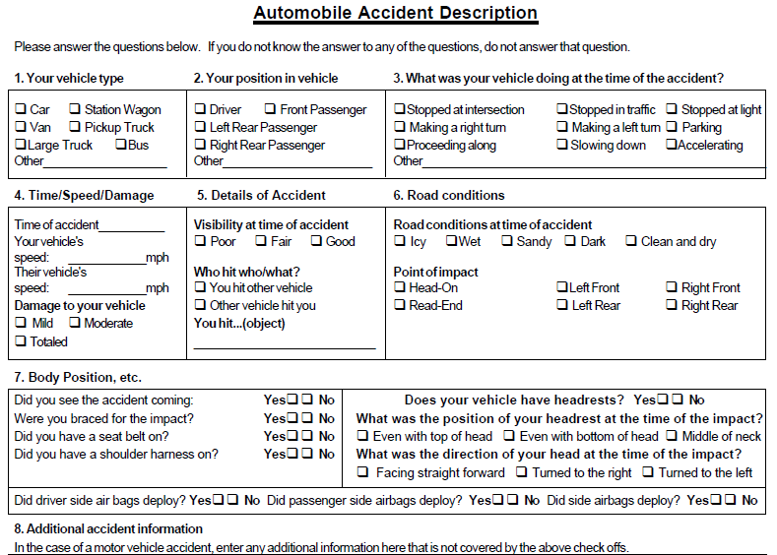8. Accident Description:
__________________________________________________________________________________________________________________________________________________________________________
9. Have you ever been in an auto accident before? Y /N If yes, when, and where did you treat? __________________________________________________________________________________________________________________________________________________________________________
10. What were your injuries? __________________________________________________________________________________________________________________________________________________________________________
11. Any previous surgeries or fractures? What? When? __________________________________________________________________________________________________________________________________________________________________________
________________________
Patient Signature
________________________
Date

